WHAT: Q&A session UK Nationals – Your Residence in Slovakia after the UK has left the EU
WHEN: 25 May 2021 at 5:00 - 6:00 pm
HOW: via Microsoft Teams (see instructions below)
About the session:
- You will receive basic information on how the UK's departure from the EU affects your residence rights in Slovakia.
- You will have the opportunity to discuss your situation with IOM lawyers.
The Q&A session does not require registration and is free of charge.
HOW TO JOIN THE SESSION: Click here to join the meeting
You can join the session through:
- your web browser in your PC
- the MS Teams app installed in your PC
- the app in your mobile phone

Using your web browser or the MS Teams app (in your PC)
STEP 1: Click on this link - Click here to join the meeting
Then choose one of the options:
- In case you prefer connecting by your web browser, please click on “Continue on this browser”.
- To use the app, please click on “Open your Teams app”.
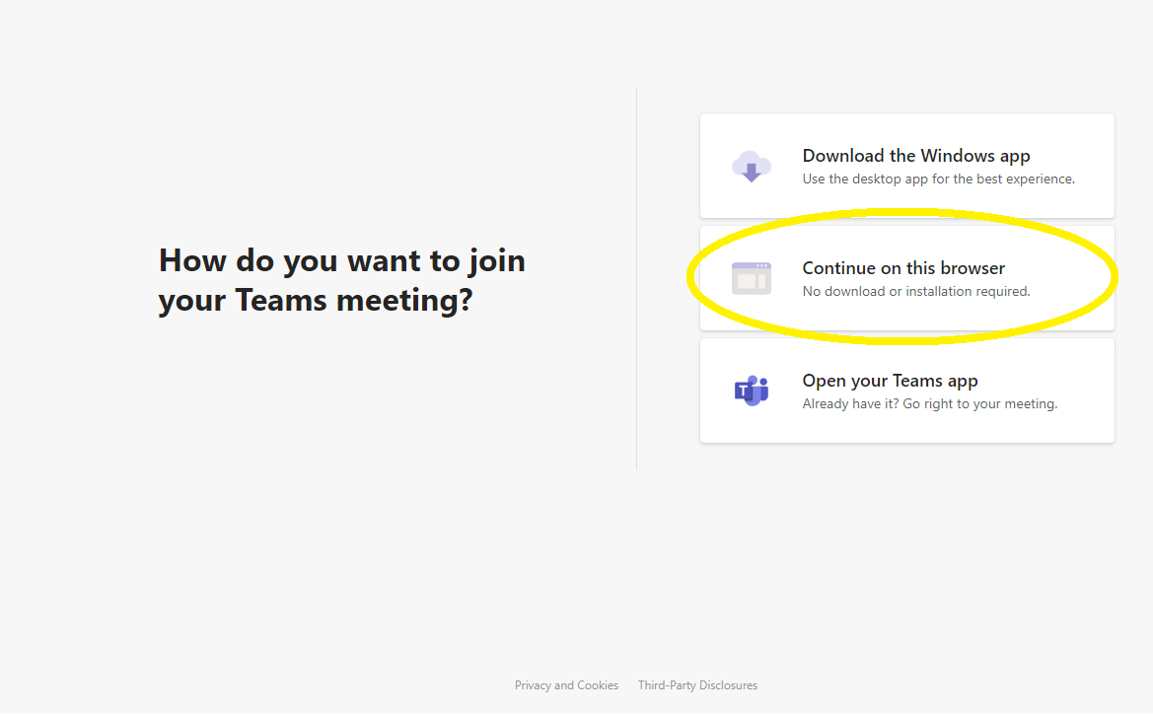
STEP 2:
Allow your microphone and camera for this webinar.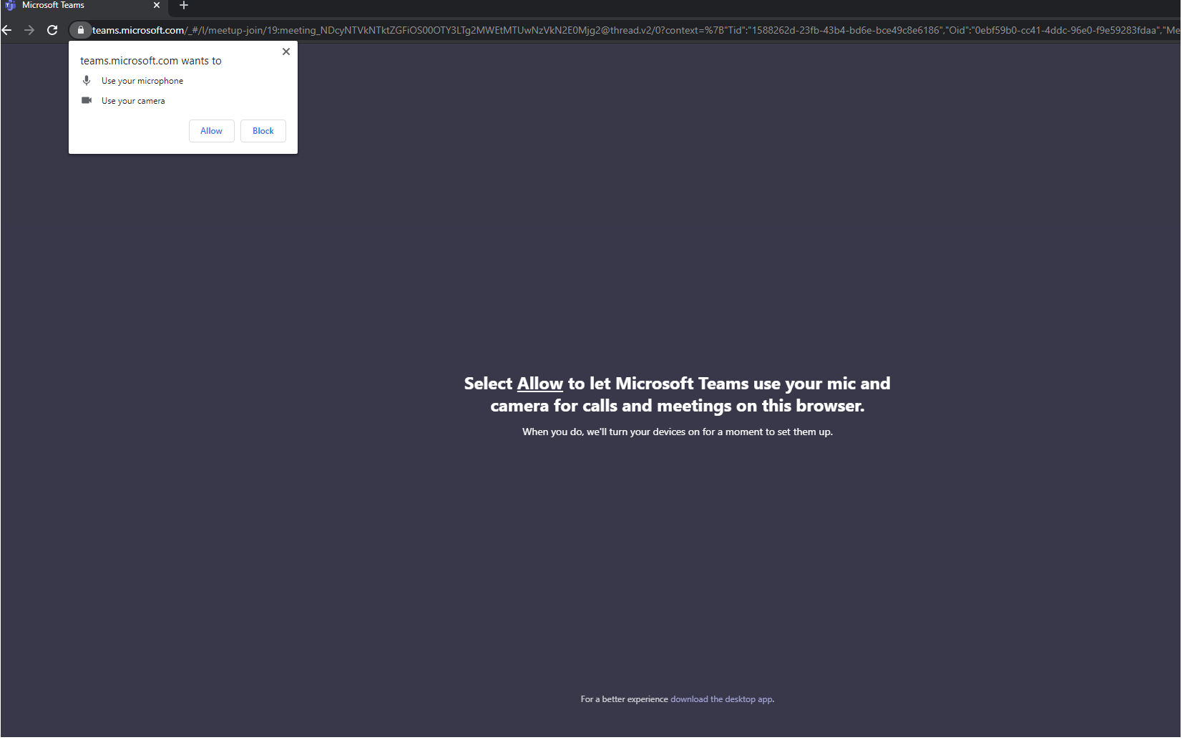
STEP 3:
Enter your full name and country of origin (for example: "John Smith, Australia") and click on “Join now” to join the webinar.
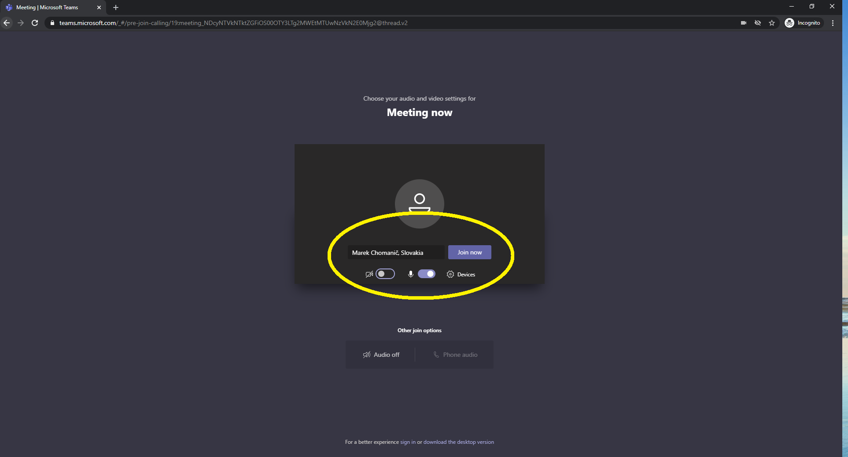
STEP 4:
When you join the webinar for the first time, it might occur that you will be placed in the lobby (waiting room). In this case we kindly ask you to wait until IOM staff allows you to join the meeting room.

Using the MS Teams app in your mobile phone
STEP 1:
Please download and install the MS Teams app in your mobile phone.
STEP 2:
Click on this link Click here to join the meeting
STEP 3:
If you already have the Microsoft account, please log in to your account to join the MS Teams meeting.
If you do not have the Microsoft account, please click on the option “Register for free”:
- Choose the type of your account: “Personal”
- Write your phone number and create a password
- Then write your name, surname, country, and date of birth
- You will get a verification code by a text message to your mobile phone. Insert it and click on “Next”.
- Log in to your account.
STEP 4:
Click on “Join the meeting”.
STEP 5:
Please write your full name and country of origin (for example: "John Smith, Australia") and click on “Continue”.
STEP 6:
When you join the webinar for the first time, it might occur that you will be placed in the lobby (waiting room). In this case, we kindly ask you to wait until IOM staff allows you to join the meeting room.
Enjoy your webinar!
If you have any problems, please contact us at UKnationalsSK@iom.int.

